**Calculator Assumed**

**Proportion, Reciprocal and Square Root Functions**

Time: 45 minutes

Total Marks: 45

Your Score: / 45



**Question One: [2, 2, 1, 2 = 7 marks]**

A crane is used to lift and assemble the concrete panels used to construct an office building. On day six of construction there are a total of 24 panels in place. Let *P* represent the number of panels and let *d* represent the number of days the building has been in construction.

1. Explain why this is an example of direct, rather than inverse, proportion.
2. Determine *k*, the constant of proportionality.
3. Hence or otherwise establish a defining rule for this situation, using the variables *P*, for the number of panels, and *d* for the number of days of construction.
4. There are a total of 44 panels used to construct this building. How many days will it take to complete the assembly of the building?

**Question Two: [2, 2, 2, 2, 3, 3 =14 marks ]**

Determine the equation of each of the following functions:

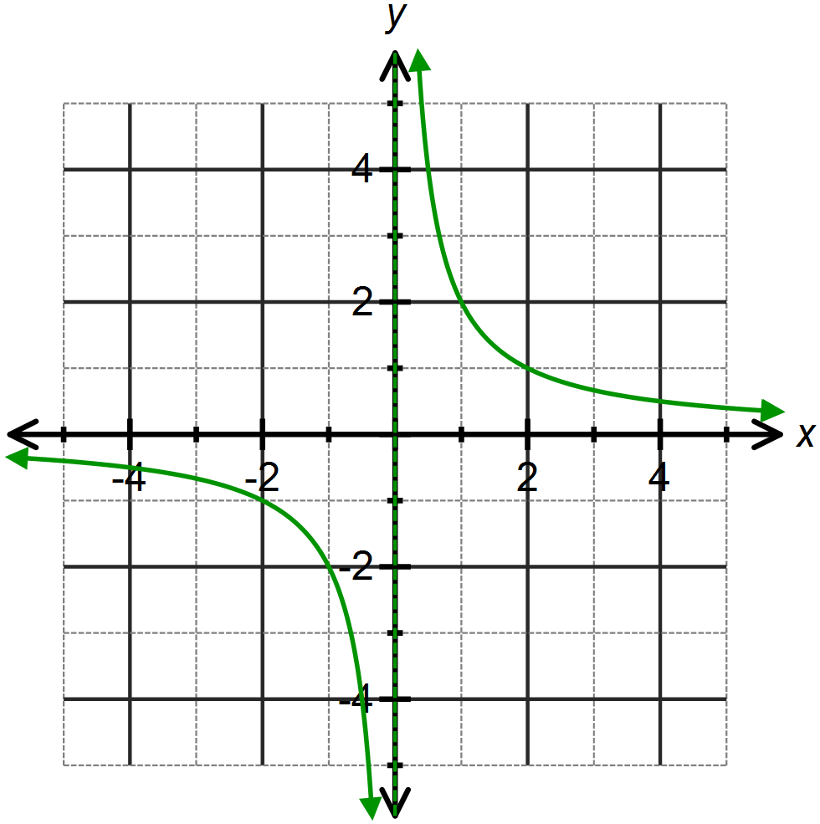

1. 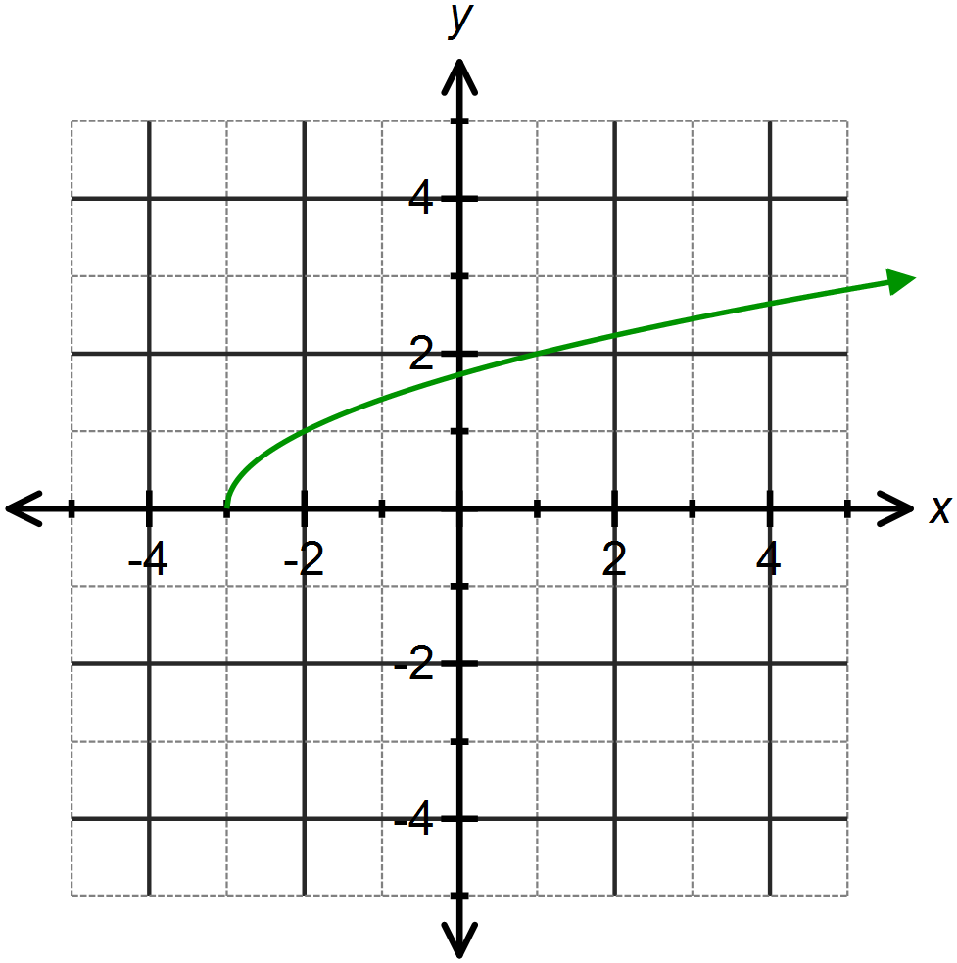
2. 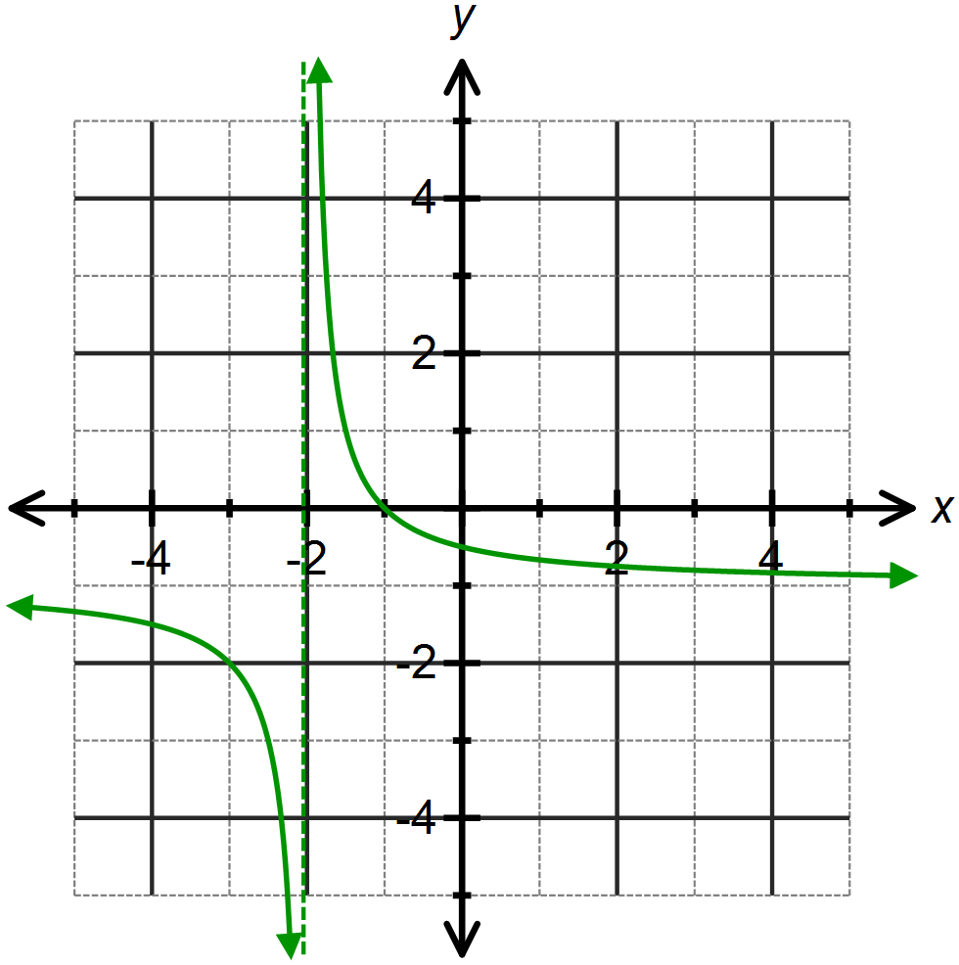
3. 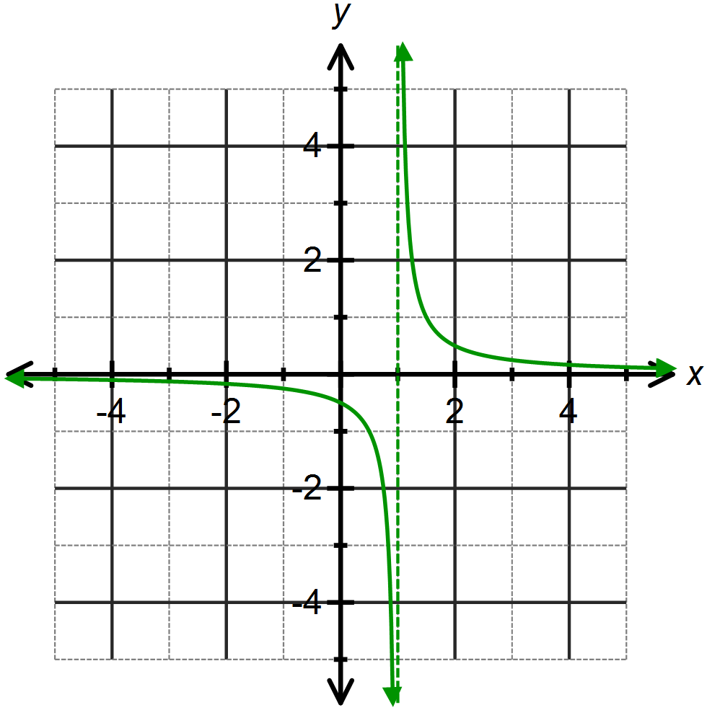
4. 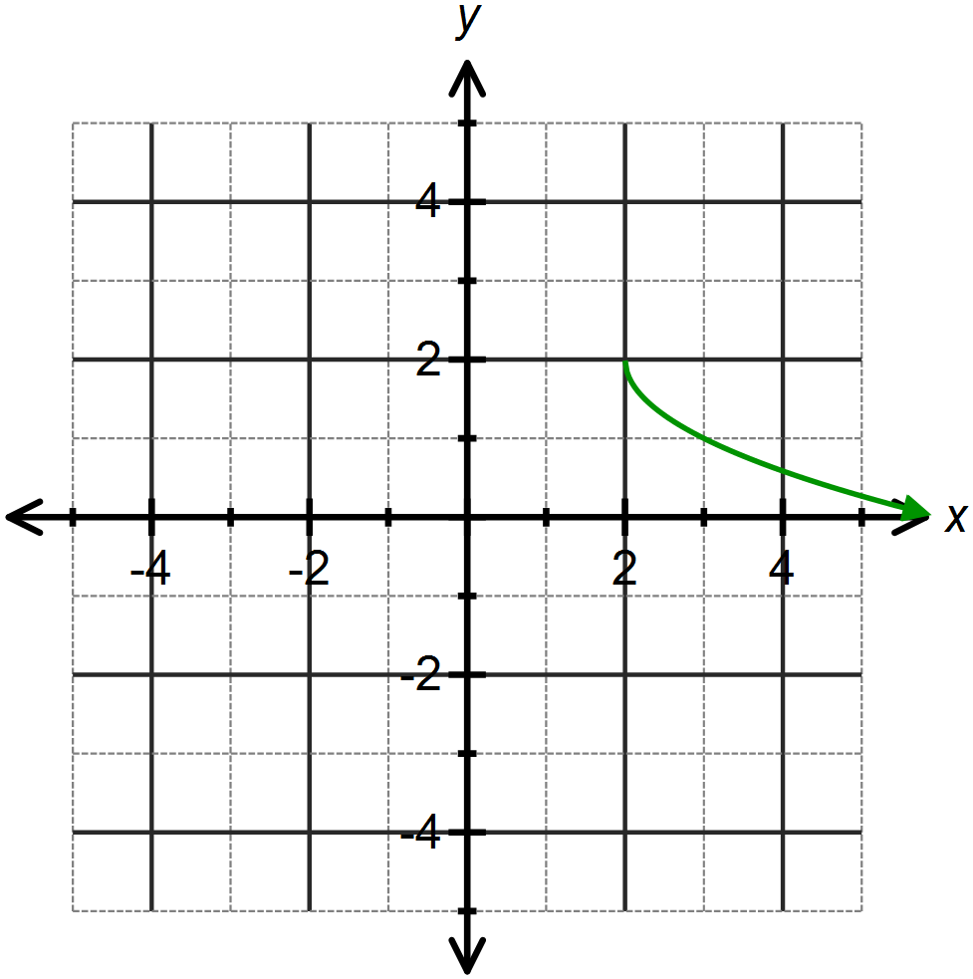
5. 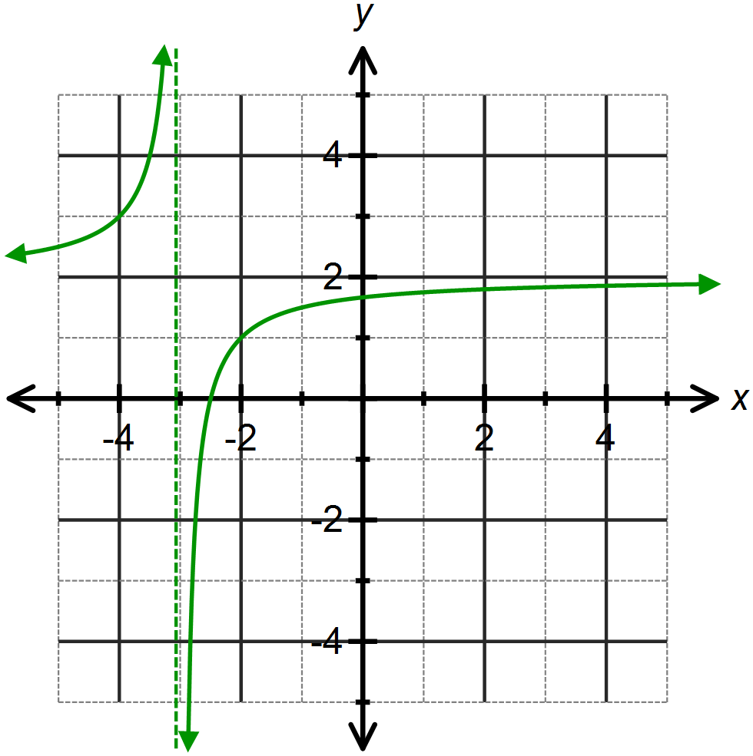

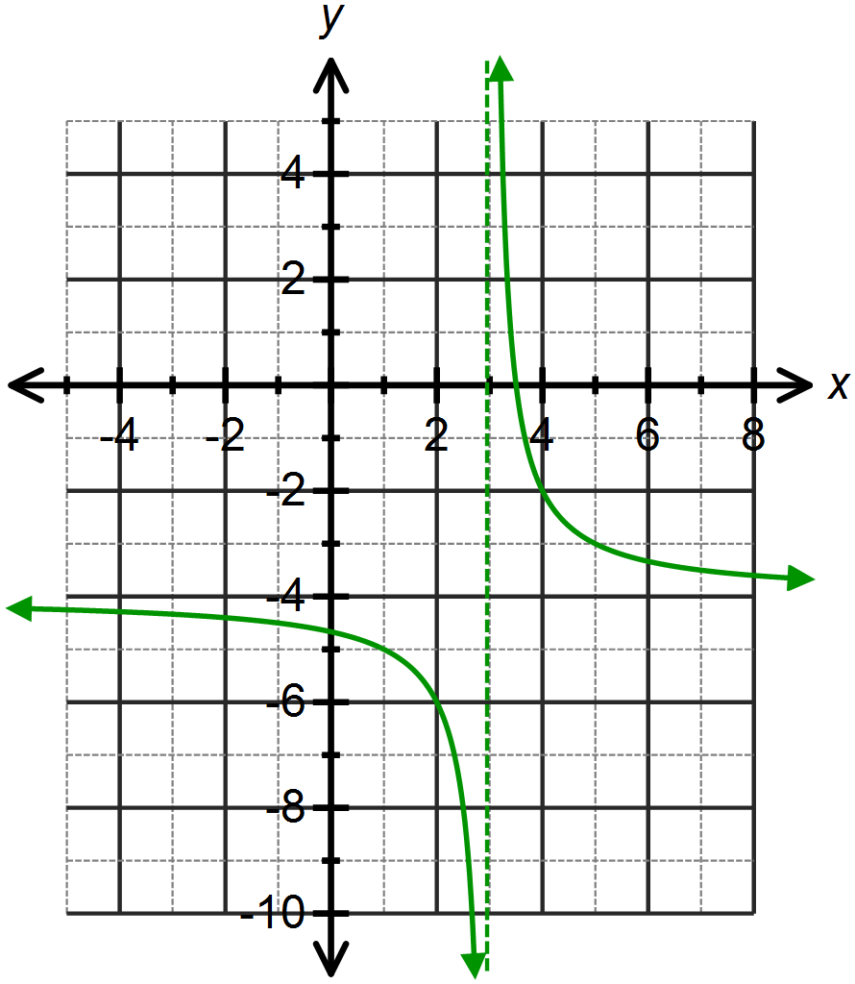**Question Three: [3, 1, 1, 2 = 7 marks]**

The function has been drawn opposite.

1. Describe the transformations that transform to .
2. For what value of *x* does the function not exist?
3. Use the graph to solve 
4. Sketch  on the axes above.

**Question Four: [2, 1, 2, 2 = 7 marks]**

The function  has been sketched below.

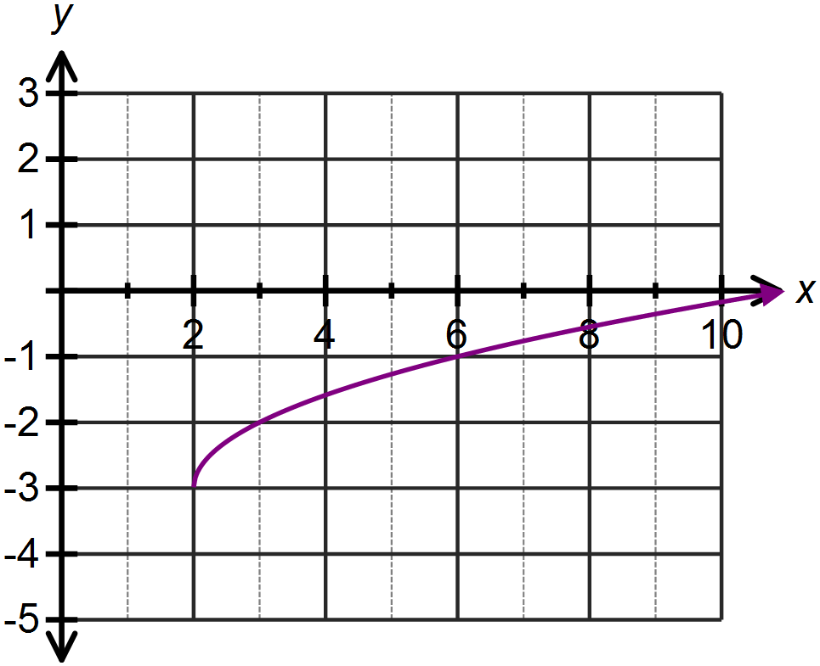

1. Determine the equation of the above function in terms of *x* only.
2. Use the above graph to solve 
3. Describe how this function has been transformed from the original function, .
4. Sketch on the axes above.

**Question Five: [2, 1, 1, 2, 2, 2 = 10 marks ]**

A teacher asks her Year 7 class to draw a rectangle with an area of 24. She then asks a few students to draw their answer on the board and each answer is different.

1. Draw three possible solutions that the students gave.
2. The teacher’s next class is Year 11 Maths Methods. She asks these students to graph each pair of dimensions of the rectangles drawn on the board. Plot your results from part (a) on the graph below.

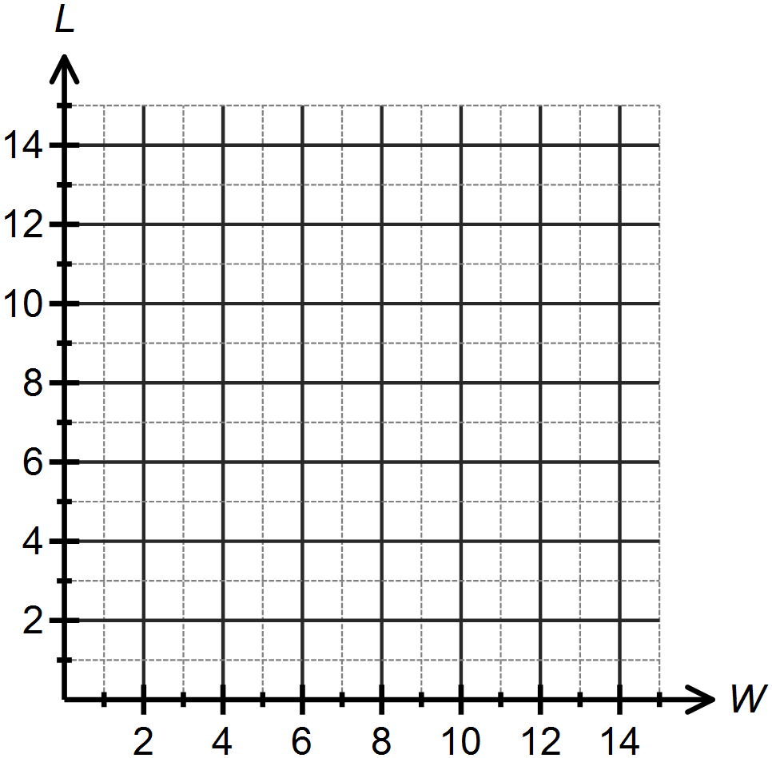

1. What type of relationship exists between the length and width of a rectangle with a constant area?
2. Determine a rule which defines the relationship for your graph in part (b) and state the value of *k*, the constant of proportionality.
3. Use your rule to find the value length of the rectangle if the width is 1.5 cm.
4. If the area of the rectangle was 10 , draw the curve defining the relationship between the length and width of this rectangle on the previous graph.
5. Using your graphs or otherwise, describe the transformation that transforms the graph from (b) to the graph from (f).

**SOLUTIONS**

**Calculator Assumed**

**Proportion, Reciprocal and Square Root Functions**

Time: 45 minutes

Total Marks: 45

Your Score: / 45



**Question One: [2, 2, 1, 2 = 7 marks]**

A crane is used to lift and assemble the concrete panels used to construct an office building. On day six of construction there are a total of 24 panels in place. Let *P* represent the number of panels and let *d* represent the number of days the building has been in construction.

1. Explain why this is an example of direct, rather than inverse, proportion.

As the numbers of days increase, the number of panels constructed increases.

1. Determine *k*, the constant of proportionality.



1. Hence or otherwise establish a defining rule for this situation, using the variables *P*, for the number of panels, and *d* for the number of days of construction.



1. There are a total of 44 panels used to construct this building. How many days will it take to complete the assembly of the building?



11 days

**Question Two: [2, 2, 2, 2, 3, 3 =14 marks ]**

Determine the equation of each of the following functions:









1. 

 

1. 
2. 





1. 

 

1. 



 



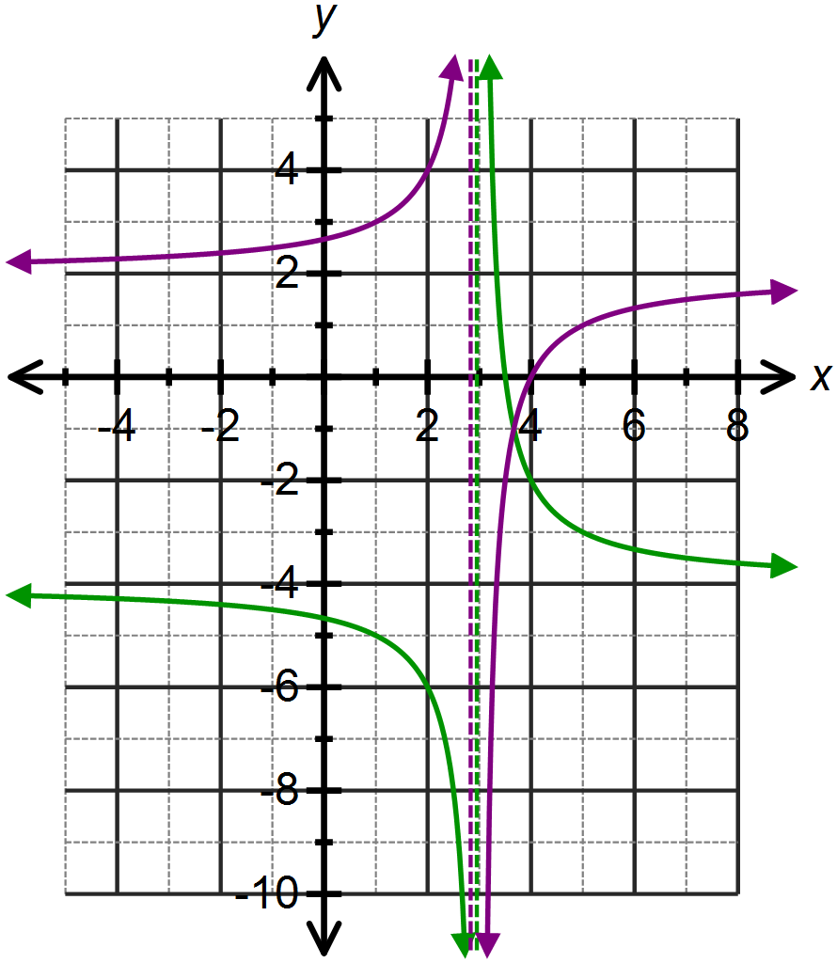**Question Three: [3, 1, 1, 2 = 7 marks]**

The function has been drawn opposite.



1. Describe the transformations that transform to .



Horizontal translation 3 units right

Vertical dilation scale factor 2

Vertical translation 4 units down

1. For what value of *x* does the function not exist?



1. Use the graph to solve 

 No solution

1. Sketch  on the axes above.

**Question Four: [2, 1, 2, 2 = 7 marks]**

The function  has been sketched below.

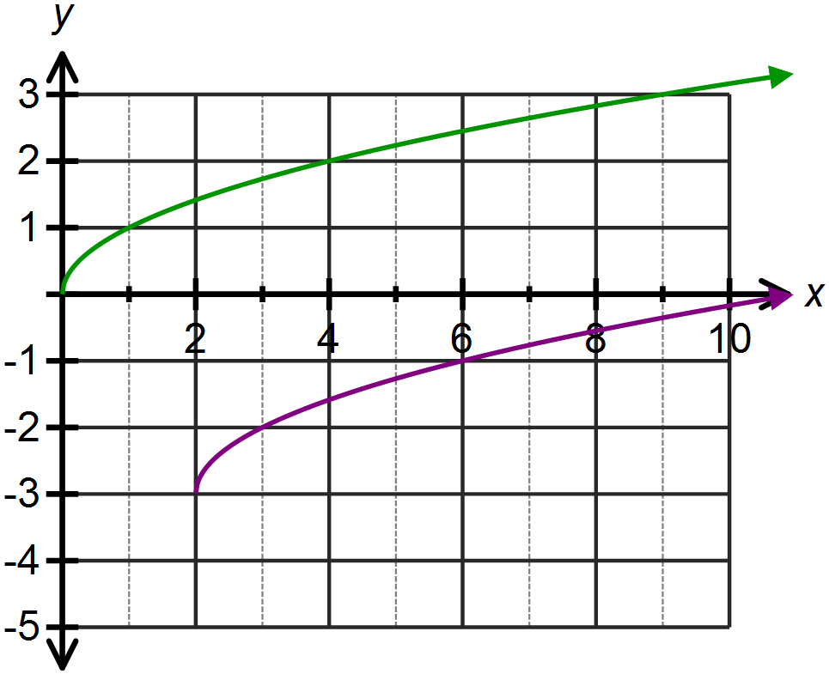





1. Determine the equation of the above function in terms of *x* only.



1. Use the above graph to solve 





1. Describe how this function has been transformed from the original function, .

Horizontal translation 2 units right

Vertical translation 3 units down

1. Sketch on the axes above.

**Question Five: [1, 2, 1, 1, 1, 2, 2 = 10 marks]**

A teacher asks her Year 7 class to draw a rectangle with an area of 24. She then asks a few students to draw their answer on the board and each answer is different.

1. Draw three possible solutions that the students gave.

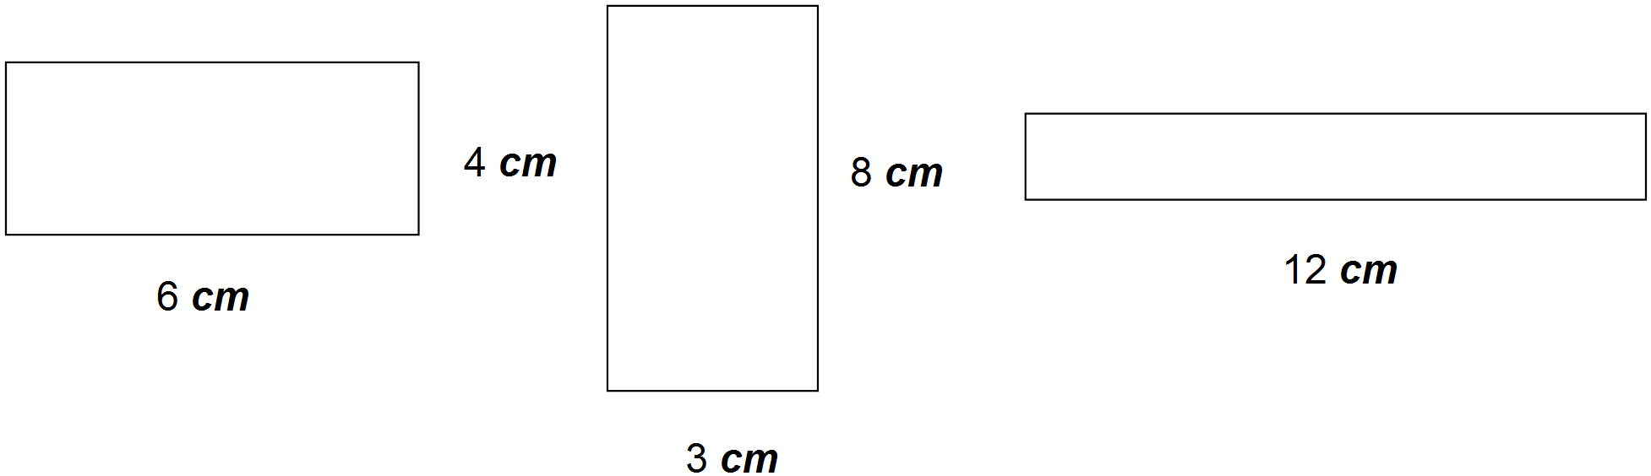

1. The teacher’s next class is Year 11 Maths Methods. She asks these students to graph each pair of dimensions of the rectangles drawn on the board. Plot your results from part (a) on the graph below.

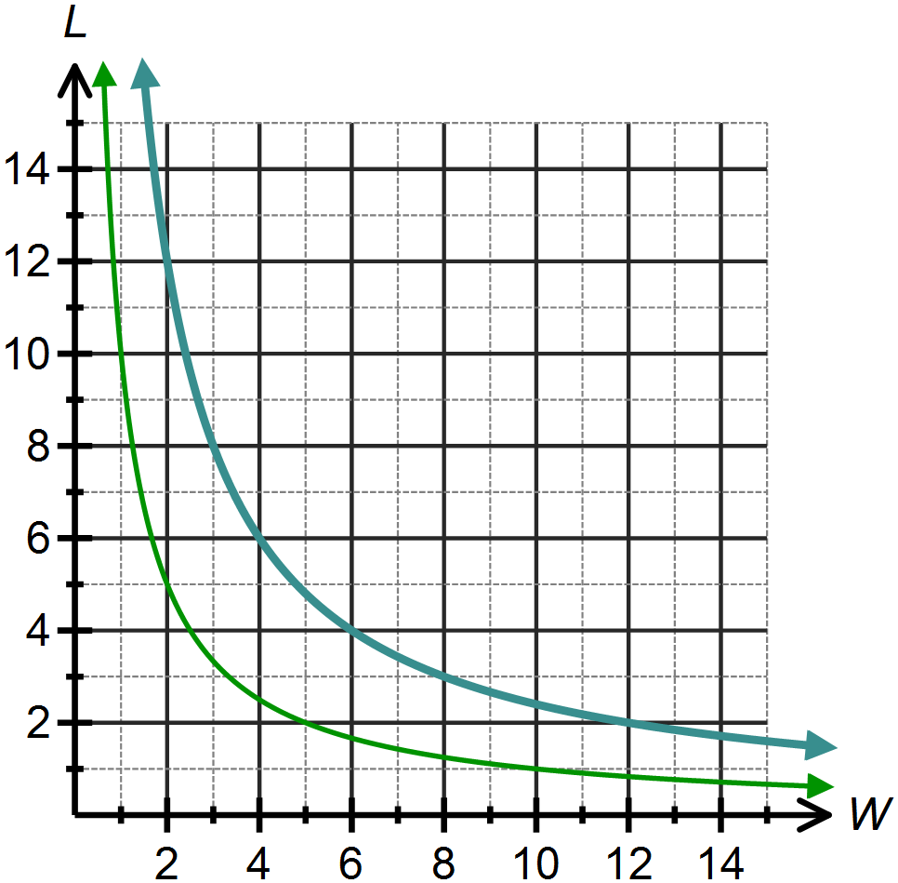





1. What type of relationship exists between the length and width of a rectangle with a constant area?

An inverse relationship.

1. Determine a rule which defines the relationship for your graph in part (b) and state the value of *k*, the constant of proportionality.



1. Use your rule to find the value length of the rectangle if the width is 1.5 cm.



1. If the area of the rectangle was 10 , draw the curve defining the relationship between the length and width of this rectangle on the previous graph.

Graph in green

1. Using your graphs or otherwise, describe the transformation that transforms the graph from (b) to the graph from (f).

Vertical dilation, scale factor $\frac{10}{24}$